4.6.1 Triple Integrals in Cylindrical Coordinates Worksheet

- Change the following points from rectangular coordinates to cylindrical coordinates.

We note that
We can see from the given point that exists above quadrant II in the xy-plane and so we need an angle in quadrant II that can satisfy and
Let .
Therefore when changed to cylindrical coordinates is .

We note that
We can see from the given point that exists above quadrant II in the xy-plane and so we need an angle in quadrant II that can satisfy and .
Let .
Therefore when changed to cylindrical coordinates is .

We note that
We can see from the given point that exists above quadrant I in the xy-plane and so we need an angle in quadrant I that can satisfy and .
Let .
Therefore when changed to cylindrical coordinates is .

- (round your angle measurement to 2 decimal places)

We note that
We can see from the given point that exists above quadrant IV in the xy-plane and so we need an angle in quadrant IV that can satisfy and
Let .

Therefore when changed to cylindrical coordinates is roughly.

- Describe in words the surface who equation is given.
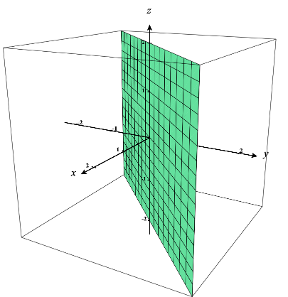

Here we note that r and z are free variables. So, our surface extends infinitely from the origin (r is free) and extends infinitely vertically in both directions (z is free). This creates the surface of a plane along the line . This plane has the equation .

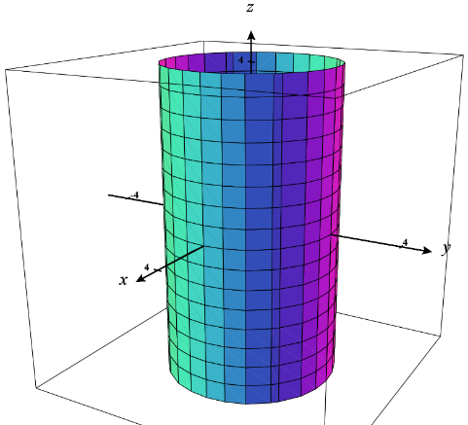
Here we note that and z are free variables. So, our surface exists while facing any direction from the origin ( is free) and extends infinitely vertically in both directions (z is free). Since r is fixed at the value of 5, we have a surface that is a cylinder with radius 5. This cylinder has the equation .

- For each of the given integrals, label the box below the picture of the corresponding region of integration in cylindrical coordinates.
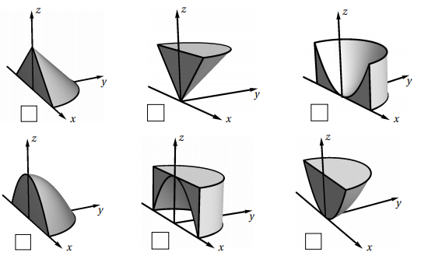

We see that the region of integration is given by:

Clearly the inequalities of imply that we are working over the top half of circle of radius 1.

The inequality of shows us that when we have and when we have . So, as r increases the range of possible z-values will continue to grow. We also notice that the change in the lower bound of z is quadratic. This leads us to conclude that the bottom middle option corresponds to our region.

We see that the region of integration is given by:

The inequality of shows us that when we have and when we have . So, as z increases the range of possible r-values will continue to shrink. We also notice that the change in the upper bound of r is linear. This leads us to conclude that the top left option corresponds to our region.

- Sketch the solid whose volume is given by the integral and then evaluate the integral.

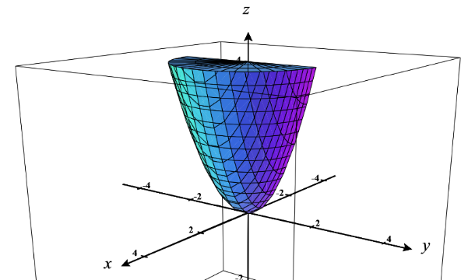
We see that our solid E is defined as .
We can rewrite the z bounds in cylindrical coordinates as .
Therefore, our solid sits above the disk of radius 2 in the 1st and 4th quadrants and exists below the paraboloid .

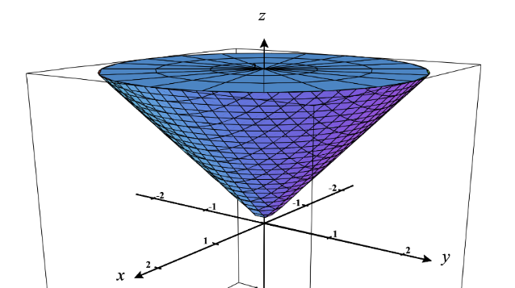
We see that our solid E is defined as .
We can rewrite the z bounds in cylindrical coordinates as .
Therefore, our solid sits above the disk of radius 2 below the cone .

- Evaluate , where E is enclosed by the paraboloid and the plane .
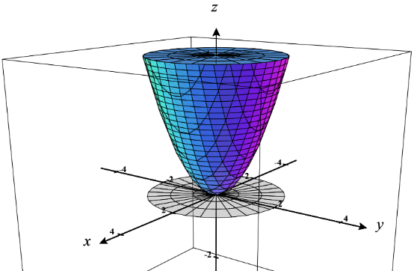
We first sketch a picture of our region E.
We can clearly establish the bounds on z as .

We project our solid down to the xy-plane and get a region D which is a circle of radius 2. We define D as
.

Since D makes us want to work in cylindrical coordinates we change our bounds on z to also be in cylindrical coordinates and we get that .

Therefore, we have that .
We then calculate

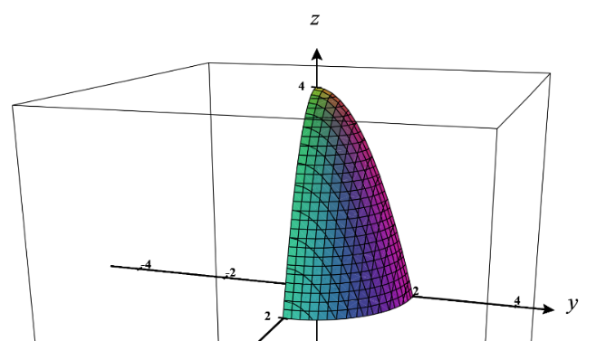
- Evaluate , where E is the solid in the first octant that lies under the paraboloid .

We first sketch a picture of our region E.
We can clearly establish the bounds on z as .

We project our solid down to the xy-plane and get a region D which is a circle of radius 2 that exists in the first quadrant. We define D as
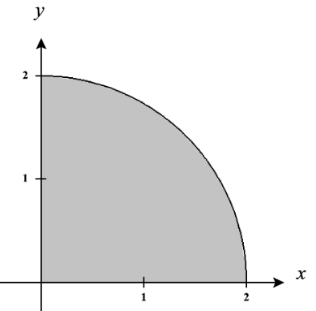
.

Since D makes us want to work in cylindrical coordinates we change our bounds on z to also be in cylindrical coordinates and we get that .

Therefore, we have that .
We then calculate
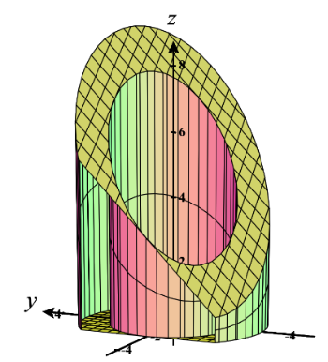
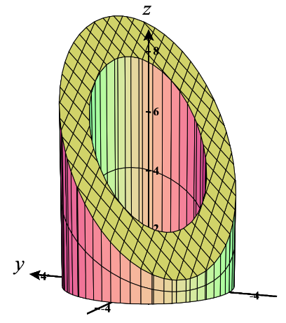
- Evaluate , where E is enclosed by the planes and and by the cylinders and .

We first sketch a picture of our region E.
We can clearly establish the bounds on z as .

We project our solid down to the xy-plane and get a region D which is a ring existing between circles of radii 2 and 3. We define D as
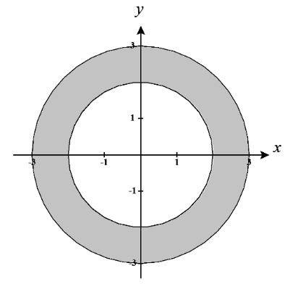
.

Since D makes us want to work in cylindrical coordinates we change our bounds on z to also be in cylindrical coordinates and we get that .

Therefore, we have that .
We then calculate

- Find the volume of the solid that lies between the paraboloid and the sphere .

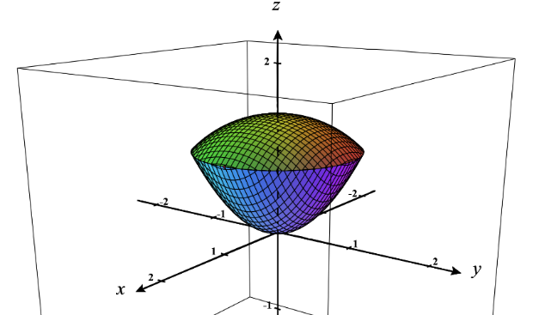
We first sketch a picture of our region E.
We can clearly establish the bounds on z as .

We project our solid down to the xy-plane and get a region D which is a circle that matches the circle at the intersection of the circle and the sphere. We solve for this intersection:
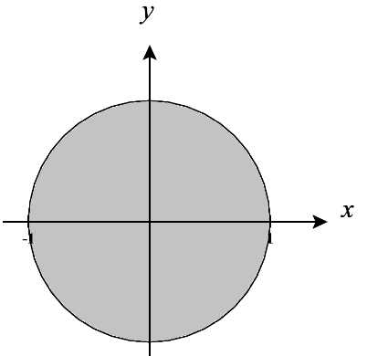
Since the first equation is impossible the second equation (a circle of radius 1) must represent the intersection. Therefore we define D as
.

Since D makes us want to work in cylindrical coordinates we change our bounds on z to also be in cylindrical coordinates and we get that .

Therefore, we have that .
We then calculate

- Convert each of the following integrals to cylindrical coordinates.

We see that the region of integration is given by:
We note that the projection of E onto the xy-plane (called D) has the following picture.
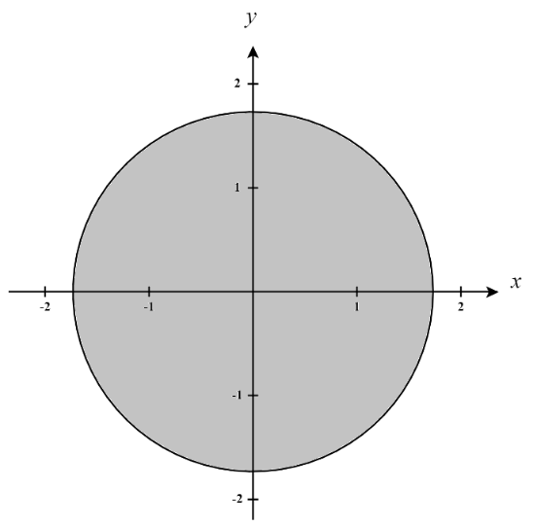

We can represent this region as

Therefore, we express the original iterated integral as

We see that the region of integration is given by:
We note that the projection of E onto the xy-plane (called D) has the following picture.
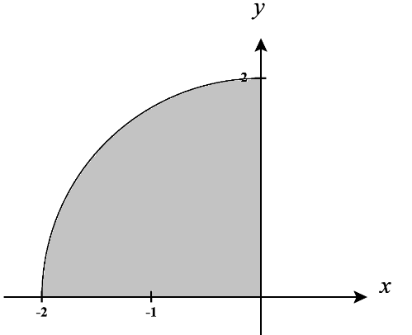

We can represent this region as

Therefore, we express the original iterated integral as

We see that the region of integration is given by:
We note that the projection of E onto the xy-plane (called D) has the following picture.
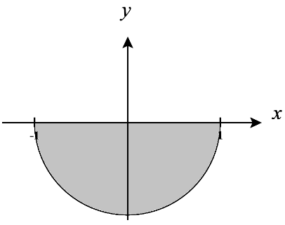
We can represent this region as

Therefore, we express the original iterated integral as .

We see that the region of integration is given by:
We note that the projection of E onto the xy-plane (called D) has the following picture.
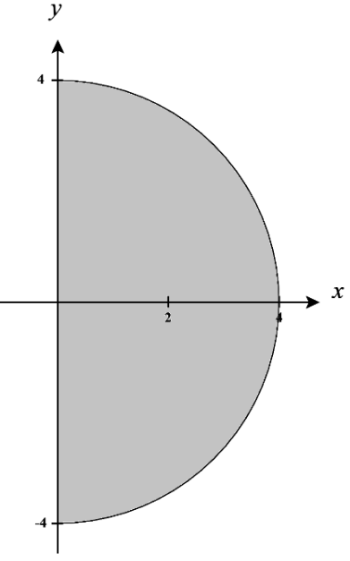
We can represent this region as

Therefore, we express the original iterated integral as .

- Let E be the solid region bounded by the ellipsoid . Let . In the following parts we will try to using cylindrical coordinates.
- Set up the integral using cylindrical coordinates without bounds first and try to determine which order your differentials should be in to make your integration as easy as possible.

We note that .
Note: Remember that the r in the numerator comes from the we obtain when we convert to cylindrical coordinates.

Based on what we have here, it appears that we could first integrate with respect to r since we have a simple u-sub we could use and integrating with respect to z first seems too difficult. We will plan to setup our differentials in the order (you could also do ).

- Fully setup up your integral with bounds.
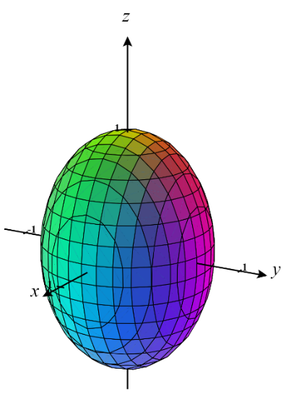
We first note that the region E has the following picture.
We can see that in this region is described by and , but we see that r changes as z changes. We can see the limits on r by observing that:
Therefore, can see that
So, the region E can be described as:

- Calculate the integral you found in (b). Hint: After integration with respect to r consider using properties of logarithms to help simplify.

